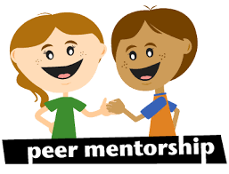

SUCCESS is looking for Peers!
Contact: Kasven1@umbc.edu

The SUCCESS Program is Maryland’s first and only four-year college program for adults with intellectual disabilities. The participants in this program attend classes to gain independent living skills and employability skills while in an integrated environment.
SUCCESS Peers work in a “student partner” roll and take classes with the SUCCESS participants. As a “student partners,” you provide support to the students while also participating in the class.

Available classes:
Networking– Mondays and Wednesdays 10-10:50am
Class focus on networking strategies and interview skills to solidify career search.
Leader of your Life – Mondays and Wednesdays from 11-11:50am
Learn about leadership, and the skills needed to be a great leader in any setting.
Legislation & Policy II – Tuesdays and Thursdays 10-10:50am
Learn about strategies for living with a disability.
Planning for Independence– Tuesdays and Thursdays from 11-11:50am
Practical applications and hands-on learning to review and apply strategies necessary for independent living.
Computers in the Workforce- Fridays 10-11:50am
Learn basic computer skills needed to succeed in the workforce such as navigating the internet and Microsoft Office.
Study Hall – Fridays 1-2:30pm
Working one-on-one with SUCCESS students on homework, projects, and goals. MUST ALSO SIGN UP FOR ONE LUNCH PERIOD
Another option is:
Lunch Peers – Mon, Tue, Wed, Thurs, Fri 11:50-1:15pm*
Supervise and eat lunch with the SUCCESS students. Only two days required to meet PRAC requirements.
